4-H Online 2.0 Enrollment tip sheet for families

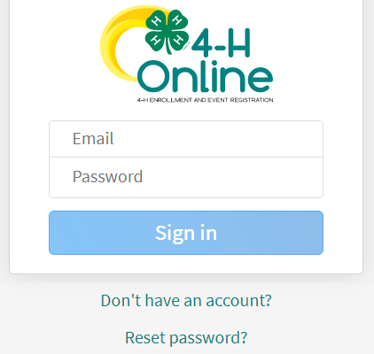
Logging in
After 14 years of using 4-H Online, Colorado 4-H is transitioning to version 2.0 (mobile friendly) for the 2020-2021 4-H enrollment year! Things are going to look very different and we thank you for your patience during this transition time as many features are still underway.

- To get started, go to our URL: co.4honline.com

4-H families that are re-enrolling
- Enter the email address and password that you previously used in 4-H Online to "Sign in". (Click "Reset password" if your password is not working)
- 4HOnline 2.0 has higher password standards, so it’s possible that your password is too short or requires additional security.

4-H families enrolling for the first time
- Be sure to contact your local county extension office prior to beginning your online enrollment.
- Click the link “Don’t have an account?”
- Select "Colorado" and then “Colorado 4-H Youth Development”.
- Select the county
- Enter your family’s contact information and set a password.
- Click "Create Account"
- Enter your family’s address information and click Verify.

Login troubleshooting
If you have previously created a 4-H Online account, 4-H Online will prevent you from creating a new account based on your email address, mailing address and/or phone number. This can sometimes be resolved with the on-screen prompts, other times staff assistance may be needed:
- Contact your local extension staff

Helpful hints: Look for the buttons!
Throughout the enrollment process, look for the Blue buttons to proceed, and ultimately, the Green button to ‘submit’.

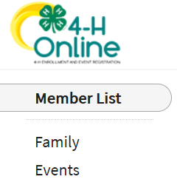
Re-enrolling previous 4-H youth members
- Click on "Member List" to see existing member records.
- Click “Enroll Now” for the member you're re-enrolling.
- Select the member’s current school Grade, click Next and then Enroll.
- Proceed through the next several screens to complete enrollment*.

Enrolling new 4-H youth members

Step 1 - create a Member Profile
- Click "Add Member"
- Click on the "4-H" program and then "Next"
- Enter the requested information on the next screens to create the new member's profile.
  - This profile will remain in place for all future enrollments and event registrations.
- Click on "I want to join 4-H as a New or Returning 4-H Member", then Finish

Step 2 - enroll in the current 4-H year
With the member's profile created, proceed through the next several screens to complete enrollment.*

* NOTE: Additional Information Tips for Enrolling
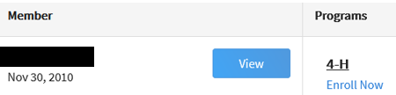
View – Allows the end-user to update the “Members” profile
Enroll Now – Allows member to begin the enrollment process answering questions such as:
Choosing a 4-H Units (Club) and Project – local extension staff should questions arise. Use the other “Blue” buttons to your advantage!
Tell Us About You and Share Information!
Share your health information isn’t required but helpful, if needed during
county, district, regional or state events. The only requirement are signatures to agree or disagree on emergency situations.
Required Consents for Members and Parents to Sign each 4-H Year (Code of Conduct, Participation, and Photo Release) – Only if a member takes an animal project the Animal Care and Housing Form is required per project.

Unless otherwise noted, all payment and questions should be directed to your local extension office. NOTE: Always check with the county for all FEES, there may be additional county and/or club fees!

What Next?
After you submit enrollments/re-enrollment, you will receive an email from the 4-H Online server as a confirmation and with more information about participating in 4-H.

- In the days following your submissions the following will happen:
Enrollment Approved – Yay!
- Enrollment Sent Back to Member – The County needs some corrections, then you would resubmit for review.
NOTE: Animal Entry Information will be coming soon! Stay tuned!

